

‘Together We Grow’

Smithdown Primary School

Behaviour for Learning Policy
Reviewed: September 2027

‘Together We Grow’

Our Key Values
Our school motto is ‘Together we Grow’.
We ensure that every child has access to a broad, balanced and supportive curriculum. Through this we are able to give our pupils a range of opportunities and experiences to grow and develop academically, physically socially and morally.

Our School Vision
At Smithdown Primary School we aim high. We want every part of our school community- pupils, parents and members of staff to experience success. Smithdown Primary School will work with everyone to create a happy, safe and stimulating setting where children are motivated to learn together. By maintaining high expectations of ourselves and each other, our children will be equipped to encounter opportunities and challenges with resilience and determination. We encourage a curiosity about the world and strive to ensure that our children will contribute positively, now and in the future.
The Behaviour for Learning Policy has been written in consultation with staff, pupils and governors of Smithdown Primary School. It follows the DfE Guidance Behaviour in Schools: Advice for headteachers and school staff (July 2022)
It is an aim of our school that every member of the school community feels valued and respected, and that each person is treated fairly and well. We are a caring community, whose values are built on mutual trust and respect for all. This policy is designed to support the way in which all members of the school can live and work together in a supportive way and is the basis of regular staff training. It aims to promote an environment where everyone feels happy, safe and secure.

Our school has just one rule – show kindness and respect. This one, simple rule supports us all in promoting good relationships between pupils and staff so that we can all work together with the common purpose of helping everyone to learn. This policy supports the whole school community in aiming to allow everyone to work together in an effective, harmonious and considerate way.

We treat all members of our school community fairly and apply this behaviour policy in a consistent way.

This policy aims to help children to grow in a safe, happy and secure environment, and to become positive, responsible and increasingly independent members of the school and wider community.

The school rewards good behaviour, as it believes that this will develop an ethos of kindness and co-operation. This policy is designed to promote good behaviour, rather than merely deter anti-social behaviour.

This policy should be read alongside the Attendance and Punctuality Policy and the Anti-Bullying Policy.

Aims:
- To teach, through the school curriculum, values and attitudes as well as knowledge and skills which will promote responsible behaviour, develop self-discipline and encourage in children a respect for themselves, for other people and property.
- To foster positive attitudes to create a caring, calm, family atmosphere in which teaching and learning can take place in a safe and happy environment.
- To encourage and reward good behaviour and to provide a range of strategies to cope with challenging situations and poor choices.
- To make clear to children the distinction between minor and more serious misbehaviour and the range of sanctions that will follow.
- To always have high expectations of behaviour and empathy for other’s feelings.
- To treat problems when they occur in a caring and sympathetic manner in the hope of achieving an improvement in behaviour.
- To create an atmosphere of honesty and trust, taking responsibility for our own actions.
- To create a safe, friendly atmosphere where children and teachers can work effectively and have opportunity to learn well.
- To remember that every lesson/day is a fresh start.

Strategies:
- To have a consistent approach to managing pupil behaviour, which contributes to the development of the attitudes and skills required to be successful, happy and socially aware.
- To ensure that the special educational needs of pupils with social, emotional and behavioural difficulties are recognised and met.
- To ensure that all staff take responsibility for maintaining good behaviour throughout the school.
- To ensure pupil behaviour is taught effectively and positively.
- To implement a stimulating and appropriate curriculum.
- To promote pupil self-esteem and a shared sense of pride and ownership through the celebration of achievement by the school community in a well-cared for environment.
- To develop an effective partnership with parents
- To ensure that high standards of behaviour will be promoted at all times.
- To annually report to the Governing Body on the effectiveness and development of this policy.
- The Head teacher and Inclusion Manager will engage with external agencies when necessary.

Roles and responsibilities:
Role of staff
- To look for, encourage and reward good behaviour.
- To treat all children fairly and with respect.
- To raise children’s self-esteem and develop their full potential.
- To create a safe and inclusive environment.
- To be a good role model.
- To form a good relationship with parents so that the children can see that the key adults in their lives share a common aim.
- To recognise that each child has individual needs.
- To use sanctions clearly and consistently.

Role of parents
- To make children aware of appropriate behaviour in all situations.
- To form a good relationship with school staff so that the children can see that the key adults in their lives share a common aim.
- To support the school in the implementation of this policy.
- To be aware of the school rules and expectations.
- To show an interest in all that the child does in school by valuing personal and social achievements alongside academic achievements.
- To ensure that their child is punctual and in school everyday
- To model good behaviour

Role of the children
- To follow the school rule.
- To be positive role models
- To support peers and contribute to the school culture.

Role of the Governors
- To agree the guiding principles of the policy.
- To monitor the policy regularly.

Rewards and Good Behaviour:
Good behaviour is promoted by the application of our one rule, which is displayed in all classrooms.
We show kindness and respect.
- A dojo system is used as an instant reward and encourages continued high standards of behaviour through the award of bronze, silver, gold and platinum badges.
- Special Recognition Award (linked to showing kindness and respect)
- Good behaviour is celebrated in weekly achievement assemblies.
- Regular, consistent praise and encouragement is part of the school ethos.
- Parents are informed when their children have exhibited great behaviour for learning.
- Visits to and from members of the SLT
- The presentation of Citizenship Award at the end of each year 6.

Sanctions
Any sanctions used by the school aim to support children in understanding the impact of their behaviour, developing positive relationships and making appropriate choices in the future. Sanctions will be fair, proportionate and consistently applied, taking into account the age, understanding and individual needs of the child. They will never be humiliating or intended to undermine a child's self-esteem.
Sanctions may include:
- Learning for Life: Where a child does not follow our one school rule, We show Kindness and Respect, they will receive a clear verbal reminder of the expected behaviour and be given an opportunity to make a positive change.
- If the behaviour continues, the child will receive a further verbal warning and a reminder that they will be moved to the cloud if they do not meet the expected standard of behaviour.
- If there is no improvement, the child will be moved to the raincloud and may be asked to spend up to 10 minutes in another classroom, where they will be appropriately supervised. This provides an opportunity to reflect, regulate and prepare to return to learning.
- Where behaviour continues or further intervention is required, a member of the Senior Leadership Team (SLT) will become involved. Parents/carers will be informed when behaviour requires escalation to SLT.
- Where a child displays aggressive or violent behaviour, a member of SLT will be involved. The immediate priority will be to ensure the safety of all children and staff, while supporting the child to regulate their emotions.
- In cases of serious or persistent unacceptable behaviour, further sanctions may be considered. In the most serious circumstances, this may include suspension or permanent exclusion, in accordance with statutory guidance.

Fresh Start
Following a consequence, children will be given a fresh start at the beginning of the next session. Staff will reinforce expectations positively, ensuring that children have the opportunity to learn from their behaviour and make better choices moving forward.
Individualised Support
- We recognise that all children are individuals, with differing levels of need, understanding and emotional regulation. Some children may find aspects of the school day overwhelming, which can impact their behaviour.
- Where appropriate, the school will work with children, parents/carers and relevant professionals to identify underlying needs and implement reasonable adjustments and additional support. This may include individual behaviour support plans, regulation strategies, access to a calm space or additional support during less structured times of the school day.
- In exceptional circumstances, where a child's individual needs mean that full-time attendance is temporarily not in their best interests, a reduced timetable may be considered in accordance with statutory guidance. Any such arrangement will be temporary, agreed with parents/carers, regularly reviewed and supported by a clear plan for returning to full-time education. A reduced timetable will never be used as a sanction or simply to manage behaviour.

Pupil Support Systems:

Pupils are encouraged to talk about significant incidents so that solutions can be found which prevent high emotional reactions. In doing so we aim to ensure that pupils maintain positive relationships and make good choices about how to deal with a range of situations.
We implement a range of support systems for pupils who are having difficulty in achieving successful behaviour for learning. This includes:
- Social Thinking intervention groups
- Assorted therapies including, MHST (Mental Health Support Team) play, drawing and talking, music.
- Zones of Regulation
- Re-Engage
- Purple Circle
- Social stories
- Brain breaks during lessons
- Sensory Breaks
- Alternative activities at lunch time
- Access to sensory rooms to reflect and calm
- Behaviour for Learning Cards

Behaviour for learning Report Cards (Appendix 2)

If a child is frequently displaying behaviour that is not in line with the one school rule, then they may be given a Behaviour for Learning Report card. This is a supportive tool to help the child focus on their positive behaviour and encourage them to make the right choices.
Steps towards a pupil being given a Behaviour for Learning Card
If a child is displaying behaviour not in line with school policy, then:
- The class teacher will speak with parents at the end of the day and record the incident on CPOMs.
- If behaviour doesn’t improve then a formal letter will be sent home to clarify that the child is at risk of being given a behaviour for learning card.
- If behaviour doesn’t improve then child will be placed on a Behaviour for Learning card for a minimum of 2 weeks.
- After a 2-week period, behaviour will be reviewed.
- When the child no longer needs the behaviour card, this will be celebrated with a letter home to parents.

Please note – for very serious incidents, SLT may place a child on a behaviour for learning card without following the above steps. Parents will always be informed.

Positive Handling
- If at any time there is the possibility of injury to the pupil, other pupils, staff, and/or damage to property then positive handling could be used by trained staff (wherever possible).
- Any incident which requires positive handling of a child is done in accordance with DFE guidelines.
- All incidents are reported to senior staff and logged on CPOMS (Child Protection Online Monitoring System)

Exclusions:
When strategies, practices and interventions have not been successful in improving a pupil’s behaviour, or the use of more significant interventions or sanctions are required, a pupil may be suspended or excluded from school.
All suspensions and exclusions will be dealt with in accordance with DfE guidance:
Suspension and Permanent Exclusion from maintained schools, academies and pupil referral units in England, including pupil movement (July 2026)
There are two types of exclusion:
- Fixed Period: Short term exclusion for one or more periods up to a maximum of forty-five days in any one school year. This can include lunchtime only exclusions. the headteacher will follow Local Authority Policy and Guidance.
- Permanent Exclusion – For a serious breach of school discipline, where the child’s place at the school may be at risk, the headteacher will follow Local Authority Policy and Guidance.

Please note that in the absence of the Head teacher, a member of the SLT who has been nominated to act on his behalf will also have the authority to exclude.

The Headteacher will inform parents/carers both verbally and in writing. This will include details of the reason for the suspension or exclusion, arrangement for the child’s return and information about home learning provided during the suspension or exclusion.

Recording of incidents:
  - All serious incidents are recorded on CPOMS and referred to the SLT.

This policy will be reviewed annually or when the need arises, and the necessary recommendations for improvement will be made to the governors.

Appendix 1 - Dojos
Reasons for receiving a Dojo (not exhaustive)
Star of the week – 5 dojos
Kindness award – 5 Dojos
1 dojo for:
Being kind, showing respect, perseverance, participating, helping others, teamwork, going above and beyond

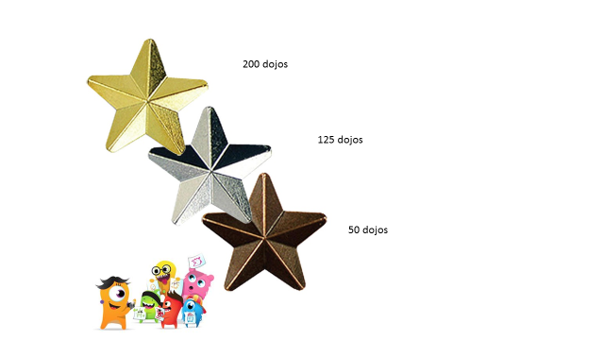
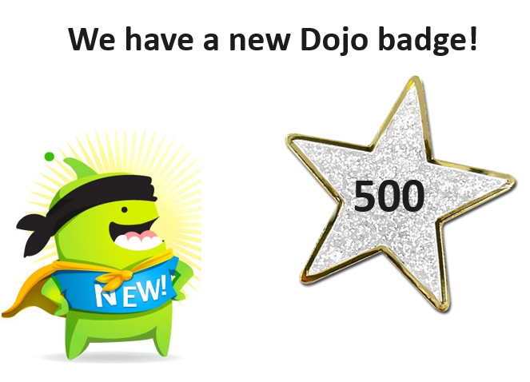
300 Dojos
200 Dojos
100 Dojos
Platinum Badge
When children receive their platinum badge, they get a special certificate and gift voucher.
Platinum badges can be worn the following year.
Award Badges – awarded when children reach a Dojo Milestone
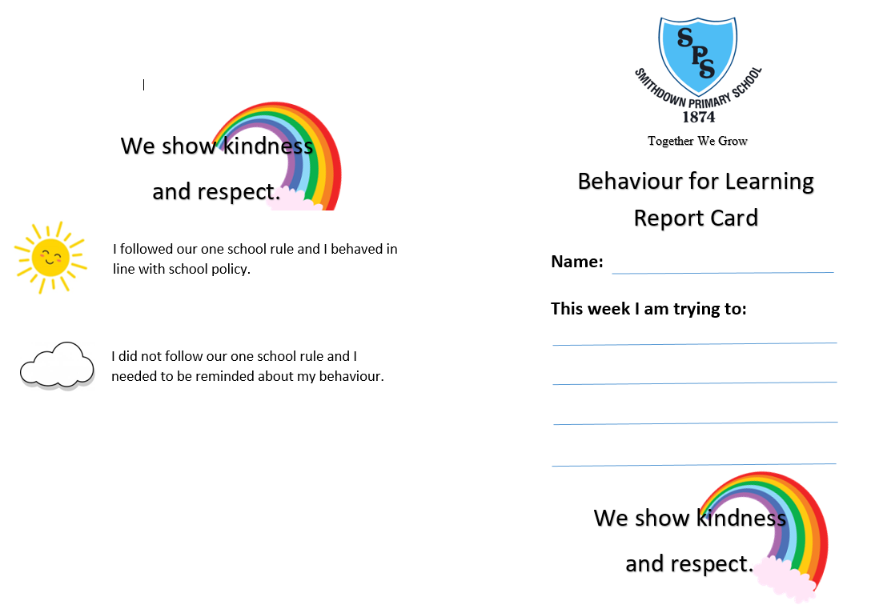
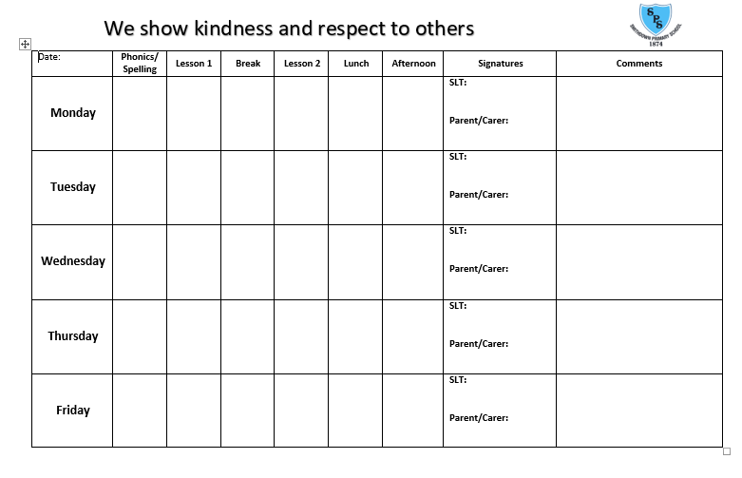
Appendix 2 – Behaviour for Learning Card

