
Schools music development plan
Supporting your school in writing your school music development plan
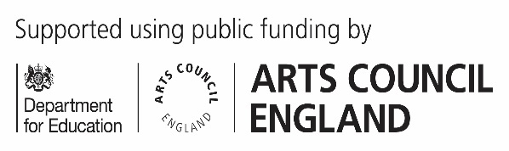
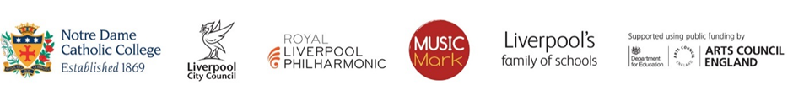
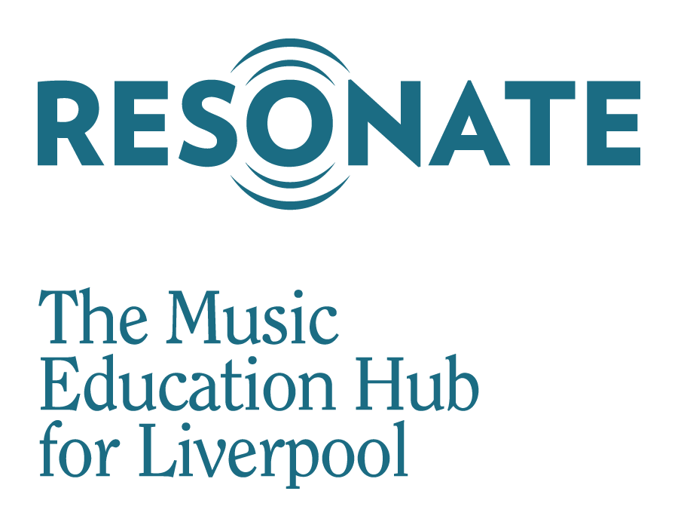
Context
On the 25th of June 2022, the government published its updated National Plan for Music. This document it outlines an expectation that…
- ‘In partnership with their music hub, we would like every school (including multi-academy trusts) to have a Music Development Plan that captures the curricular and co-curricular offer and sets out how it will be staffed and funded.’
The deadline for the first edition of this document is September 2023.
Update: On 15th May 2024 DfE announced all schools must publish their School Music Development Plan on their website by 1st September 2024
Aim
The School Music Development Plan should set out how the school will deliver high quality music provision for all pupils in the three areas of curriculum, co-curricular and enrichment. This document will enable you to reflect on your current music provision, to celebrate success and to identify areas of development. It should set out how your school delivers its music curriculum and ensures the follow expectations are in place:
- timetabled curriculum music of at least one hour each week of the school year for key stages 1 to 3
- access to lessons across a range of instruments, and voice
- a school choir or vocal ensemble
- a school ensemble, band or group
- space for rehearsals and individual practice
- a termly school performance
- opportunity to enjoy live performance at least once a year

Outcomes
- To enable schools to engage critically with their music offer.
- To feed music into wider school improvement.
- To open a constructive dialogue with music hubs, both to enhance in-school provision and to connect pupils to broader opportunities.
- To publicise schools’ music offer, including on the school website, so that pupils and parents have a good understanding of what to expect.

School Music Development Plan – Resonate Hub example template
To help you to complete this development plan, the following documentation may be useful:
- The power of music to change lives - A National Plan for Music Education
- Research Review Series - Music
- Model Music Curriculum
- Resonate Sounds – A framework for Whole Class Instrumental Tuition
- School Music Development Plan – DfE summary template
This template has been created by Resonate with the intention of supporting schools in creating a School Music Development Plan.
We understand that you may wish to take only a few elements from this form, and that not all aspects of it will be suitable for your setting. Please feel free to take what you need from this form; it is intended to help support the development of music in your school.

PRIMARY/SECONDARY

School: Smithdown Primary School
Music co-ordinator: Abby Carpenter
Head teacher: Phil Horne
Date written: 19.6.24
Edition number: 1
Dates reviewed (To be reviewed every… term )
Date | Date | Date | Date | Date | Date
17.7.24

The following tables illustrate the ideal standards of music delivery in schools, and allow you to describe your current standard, and define areas for improvement.

Area of provision | What we are currently doing well at in this area:  *Evidence of practice. | Area for development: make them SMART (specific, measurable, achievable, relevant, time-bound). | Action to be taken and  deadline date:
Curriculum |  |  | Action to be taken and  deadline date:
We have embedded a high quality, ambitious music curriculum throughout our provision, covering progression within the national curriculum. This includes planned assessment throughout the year to track progress, using a range of methods. | Link to curriculum online  Mrs Naylor follows Model Music Curriculum (year 1 – 6)  EYFS follow Kodaly practice alongside other approaches and methodologies.  Mr Humphries follows Model Music Curriculum (year 4 and 6)  Planned assessment each term highlighting more able pupils for further opportunities and any pupils who may benefit from music therapy/RMS | Have regular meetings with all music staff to ensure progression is in place. | October 2024
Our curriculum is fully inclusive and can be accessed by all pupils. Every staff member has knowledge of all pupil needs. | Staff meet regularly with SENCO and class teacher, informal chats on a regular basis with class teachers.  OHMI adapted instruments for ukulele year 4 - physical needs and neurodiverse needs | Make sure all visiting music specialists have the opportunity to meet with SENCO. | October 2024
Our curriculum includes listening examples from a wide range of cultures and traditions. | We have started this journey and begun to make conscious efforts to include a diverse range of composers to aid the decolonisation of the curriculum | Start to record lists of diversity used in our music repertoire. | October 2024
We have timetabled curriculum music of at least one hour each week of the school year (KS1 to KS3). | Link to timetable | Most pupils receive 30 minutes of music curriculum. Record extra hours eg singing assembly, music workshops, music clubs, Christmas performances etc | October 2024

Co-curricular
We have provided EYFS/ KS1/KS2 access to instrumental opportunities. We have also provided KS2 access to instrumental lessons. (Whole class instrumental music sessions, opportunities to continue on from whole class instrumental sessions e.g. small group/1:1 tuition). (Visiting specialist musician/class teacher willing to teach a small group).  KS4&5 as appropriate to exam board expectations. | See planning  Currently  EYFS – year – 3 access to whole class tuned and untuned percussion at various stages of the curriculum. Also exposed to other instruments via Mrs Naylor bringing in instruments to inspire pupils.  Year 3 – recorder and glockenspiel  Year 4 – whole class instrumental (ukulele)  Year 5 – opportunity to access trumpet club. Year 5 also access instruments in their curriculum (glockenspiel)  Year 6 – whole class ukulele (due to change to guitar by 2026) | Continue with offereing access to wide range of instruments.  Try to offer more workshops. Include a music day in June  Continue to encourage more able and eager pupils to attend Resonate after school on a Tuesday. | October 2024
We have provided access to singing opportunities within the curriculum and singing assemblies for students in KS1-4. | Pupils receive singing opportunities in every music lesson.  SInging assembly provides opportunity for pupils to sing in larger group.  Year 2 access ising | Make singing assembly available for EYFS – year 3 throughout the year.  Look at timetable to rework when singing assemblies will work best.  Year 2 to access ising again next year.  Possibly Smithfest opportunitiy to sing and learn Beatles songs.
We have identified children who are entitled to pupil premium funding. We have opened up opportunities for these children to access instrumental and vocal tuition. | Due to high numbers of pupil premium, all pupils receive quality music lessons from specialist teachers to open up opportunities.  Music therapy offered to indiviuals who are highlighted by class teachers. | Print off a list of pupils with PP and SEND and ensure that they are offered opportunities. | October 2024

Enrichment
We have established a school choir and/or vocal ensemble along with planned performances. | We have had KS1 singing club  Weekly singing assemblies | Repeat next year  Arrange for year 3 to have choir for Autumn and Spring term, during lunch time.  Summer term offer choir for year 2 to prepare for ising.  Plan for some performances throughout the year | December 2024
We have established a school ensemble/band/group along with planned performances. We ensure that parents are aware of the opportunities available to students both in school and in the area. | RMS offered to all pupils and parents are encouraged to take their pupils.  Year 4 and 5 have trumpet club weekly.  Year 4 and 5 perform for parents in celebration assembly  Year 6 all learn ukulele and perform. | Make list of performances  Continue to promote pupils going to RMS. Possibly transport some pupils to resonate on a Tuesday evening | December 2024
We have arranged a space for rehearsals and individual practice in school. | Classrooms are used for clubs, upstairs hall is used for whole class instrumental.
We have termly school performances.
We have organised opportunities for the children to enjoy live performance at least once a year. We embrace a variety of musical genres and styles to allow students to access a diverse cultural experience. | Year 6 went to theatre to see Wizard of Oz  Year 2 African drumming group and ising  KS2 pantomine  Whole school (EYFS – yera 6) chinese new year performance  Diwali dance whole school. | Create list of opportunities. – resend list  Create more opportunity for pupils to perform for other pupils

Authors: Grainne Naylor, Vicki Hambleton, Mark Jones and Jonathan Dickson

