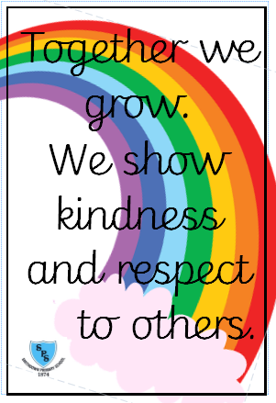****

**Useful Information**

PE days: 4KM will have PE every Wednesday. 4JS will have PE every Thursday.

Homework: Children will receive spellings and Mathematical facts every Friday as their homework. There will be a spelling test every Friday too.

Class twitter: @SmithdownPrimY4

School Website: <https://smithdownprimary.com/>

**English** 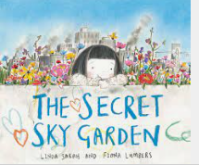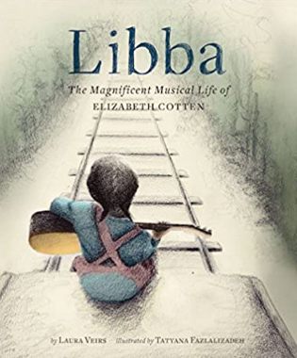

Units of work based around the books The Secret Sky Garden by Linda Sarah and Fiona Lumbers, Libba by Laura Veirs and Leaf by Sandra Dieckmann.

Writing Outcomes:

Autumn 1 – Transformation narrative and biography

Autumn 2 – Outsider narrative and non-chronological report

**Maths**

Number and Place value

* count in multiples of 6, 7, 9, 25 and 1,000
* find 1,000 more or less than a given number
* count backwards through 0 to include negative numbers
* recognise the place value of each digit in a four-digit number (1,000s, 100s, 10s, and 1s)
* order and compare numbers beyond 1,000
* identify, represent and estimate numbers using different representations
* round any number to the nearest 10, 100 or 1,000
* solve number and practical problems that involve all of the above and with increasingly large positive numbers
* read Roman numerals to 100 (I to C) and know that over time, the numeral system changed to include the concept of 0 and place value

**Staff**

Teachers: Miss Meneely and Mrs Size

Learning Support Assistants: Miss Brown and Miss Qasem

**We have one school rule for pupils, staff, parents and visitors.**

**Welcome message**

Welcome back to school to all our children and families.

We hope you had a wonderful summer break and are all ready to begin the new school year.

We are very excited to start a new year with our lovely children and cannot wait for lots of learning and fun!

The Year 4 Team. ☺

Autumn Term Curriculum Overview for Year 4



**Science**

Sound

* identify how sounds are made, associating some of them with something vibrating
* recognise that vibrations from sounds travel through a medium to the ear
* find patterns between the pitch of a sound and features of the object that produced it
* find patterns between the volume of a sound and the strength of the vibrations that produced it
* recognise that sounds get fainter as the distance from the sound source increases

Together we Grow



**Art /DT**

Story Telling through drawing

The children will use drawing to story tell.

Textiles (2D Shape to 3D product)

The children will use sketching to create a design fit for its purpose and user. They will create Christmas stockings using sewing techniques.

**RE**

What does it mean to be a Hindu in Britain today?

What does it mean to be a Christian in Britain today?

*Living*

*Living*

**Computing /Music**

CAD designing a product.

Brass Instruments

The children will have the opportunity to learn a brass instrument throughout the year.

**PHSE**

Being me.

Celebrating differences.

**PE**

Fundamentals and ball skillsFundamental movement skills include balancing, running, jumping, catching, hopping, throwing, galloping, skipping, leaping and kicking.

**Geography /History**

Geography

Coastal Processes and Landforms.

History

The Victorians.

**Spanish**

Self, family and friends.

Counting to 40.