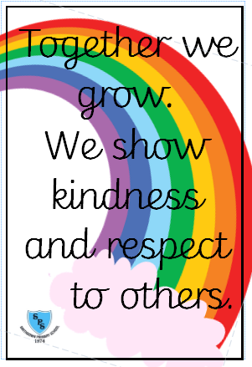****

* Previous reception experiences and counting within 100.
* Comparison of quantities and part-whole relationships.
* Numbers 0 – 5.
* Recognise, compose, decompose and manipulate 2D and 3D shapes (this will continue in Spring term).

**We have one school rule for pupils, staff, parents and visitors.**

**English**Books and writing genresSaving Mr Hoot - Narrative  
Rapunzel – Instructions   
Last Tree in the City - Environment narrative  
Christmas poetry

Christmas Poetry structions)

**Maths**

**Useful Information**PE days: 1CP will have PE every Thursday and 1RMc will have PE every Friday.   
Homework: Children will receive spellings and Mathematical facts every Friday as their homework. There will be a spelling test every Friday too.   
  
 Class twitter: @SmithdownPrimY1  
 School Website: <https://smithdownprimary.com/>

**Staff**

Teachers: Mrs Power, Miss McConnell & Mrs Carpenter

Learning Support Assistants: Mrs Carroll, Miss Jones, Mrs Hinks and Ms Khan

**Welcome message**

Dear children and families,

We hope you have had a lovely time over the summer break and we are sure you are now ready to start the new school year, so welcome to Year 1!

We are looking forward to seeing you learn lots of new things and have lots of fun!

The Year 1 Team ☺ of fun!

Autumn Term 1 Curriculum Overview for Year 1



**SEASONAL CHANGES – ONGOING**Pupils will understand how weather conditions vary in each season and how the day length also varies throughout the year.

**ANIMALS INCLUDING HUMANS**Pupils will be familiar with a variety of common animals and will be able to identify which are carnivores, herbivores and omnivores. Pupils will understand parts of the human body and its senses.

**WORKING SCIENTIFICALLY**Pupils will ask simple questions and suggest answers using observations and ideas. They will also identify and classify.

Together we Grow

**Science**

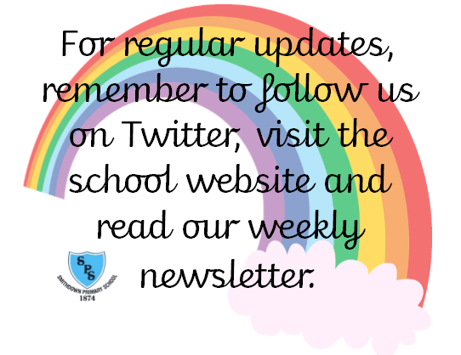

Who is a Christian and what do they believe? - *Believing*

How and why do we celebrate special and sacred times? - *Expressing*

**RE**

**Computing /Music**

**What is a computer?**

Digital literacy and IT

**What is a computer?** Basic Computing Skills &

Producing Digital Media

**Music -** Use their voices expressively and creatively by singing songs and speaking chants and rhymes

Listen with concentration and understanding to a range of high-quality live and recorded music

Fundamentals & Ball Skills

**PE**

**Special People**

What makes people special?

*Christianity, Judaism*

* Being Safe
* Rights and responsibilities
* Owning the learning charter

Consequences

**PHSE**

**ART/DT**

**Art**Spirals (drawing & sketching)

**DT**Mechanisms (Sliders and Levers)  **-** Moving minibeasts

**History/Geography  
  
History**How has childhood changed from then to now?

**Geography**What is in our local area?