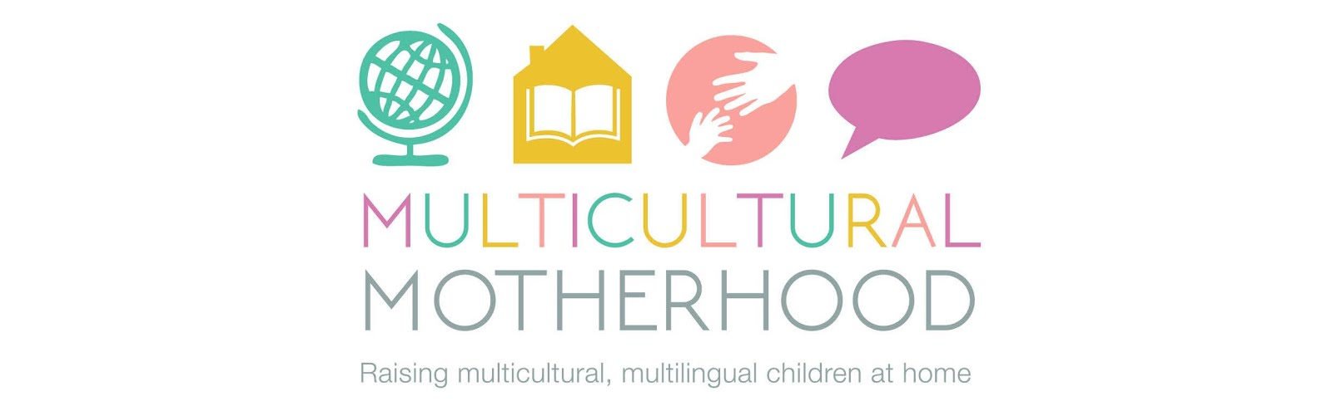

HOMESCHOOLING TIPS AND RESOURCES FOR EAL FAMILIES

*This is an extract from an article in Multicultural Motherhood.

*School closures mean that everyone is now temporarily homeschooling and many parents are anxious about this. It is perhaps even more worrying for families who have English as an additional language. Parents may be feeling overwhelmed with the workload being sent to their children and with the thought that they may have to help their children complete it in English.
Parents should carry on speaking their home language with their child. It is important that they understand that their primary role should be maintaining the home language.

Parents will want to know how they can support their child's education when using their home language so I will now share some resources I have come across that should help.
Use resources in your home language
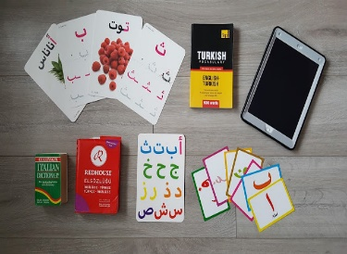

It would be great if parents could find resources, in their home language. This may mean looking for information produced by their country of origin for homeschooled or schooled children. Children all over the world are being homeschooled right now and it is likely that many governments have developed online resources to help them with their education. Search google using words in your home language and see if you can find some. It may mean your child will be following a different curriculum, but does that matter? I don't think so. All learning is relevant to growing as an individual.
Projekt Alpha is a Polish YouTube channel that has been set up by scientists to teach all sorts of scientific facts and concepts to children during temporary homeschooling.
Here is a website that has online resources for the Polish curriculum.

Choose resources based on English proficiency rather than age
Use online resources that the child can access themselves. If they have audio or visual parts that can be a great help if the parent cannot read English that well. There are some great website out there, such as BBC Bitesize, that offer online lessons based on the National Curriculum. BBC Bitesize is actually offering daily lessons for homeschooling at the moment which may be helpful. If the child's level of English is not that great, they can try doing lessons aimed at lower year groups. There is no point them trying to do work that they cannot understand. Choose lessons based on the child's English proficiency rather than age.

Use online audio or visual resources
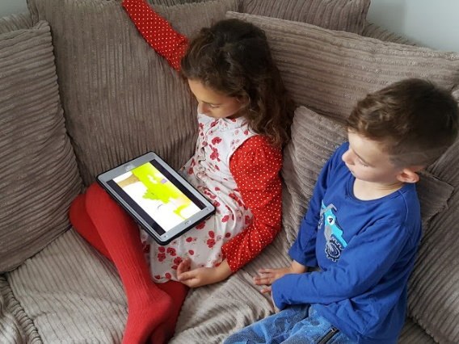

Online resources that include an audio or visual may really help children whose first language is not English. They will not have to read so much so it will remove a burden both for the child and the parent. There are some great websites which include such resources.

Audiobooks and ebooks in the minority language
If you do not have any books in your home language you can allow your child to read or listen to ebooks in the minority language instead.
Audible is another company offering free audiobooks during school closures. It has audiobooks in a variety of different languages too!

Key term books
These are available on Mantra Lingua and are basically dictionaries of vocabulary used in different subjects such as English, Maths, Science and Geography. The text is in English but if you can click on the word and you will hear the word in a language of your choice and then hear an explanation of the word. This is a really great way to increase vocabulary in a specific subject and also a great way to help EAL children understand what certain words mean.

Watch TV in the minority language
Netflix offers subtitles and also has a variety of language options for audio. Check it out and see how many programmes you can find with audio in your home language! If you would like to use a screen for some English input, you can switch on the subtitles in your home language. Research suggests that listening to the audio in the second language while reading subtitles in the first language can actually be quite a helpful tool to assist the acquisition of the second language.

