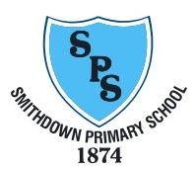

At Smithdown Primary School, we believe art education stimulates creativity and imagination whilst giving the child unique opportunities to develop intellectually, emotionally, physically and socially. Here at Smithdown, we teach art as both an individual subject as well as incorporating it into other curriculum lessons

 | Autumn | Spring | Summer
Year 1 | 3D Sculpture  Junk model Local buildings around our school. | Drawing/Portraits Famous Artist Roy Lichtenstein | Paint- Water Colours/Hot and Cold, GFL houses  (Linked to Turner/O’Keefe.
Year 2 | 3D Sculpture  Clay animal sculptures | Drawing  Local Artist study- Frieda McKitrick | African Textiles/Print
Year 3 | Sculpture  Keith Haring | Toning/Shading/Mixed  Media/Print Making Chinese Art | George Seurat/Pointilism
Year 4 | Mosaics- Looking at mosaics from Romans and  Gaudi and comparing | Painting  William Morris | Drawing-  Sketching  Significant buildings around Liverpool
Year 5 | Sketching / Different Media  Artists of WW2 | Abstract art  Space | Early World Islamic Art
Year 6 | Mixed Media linked to History – Ancient Greece | Mixed Media and printing linked to History:  Make a Freedom Quilt | Artist Study

