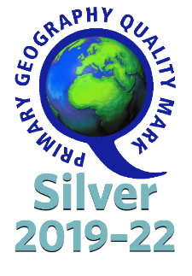
Geography Overview

At Smithdown Primary School we believe that Geography enables children to make sense of the complex and dynamically changing world that they live in. Our aim is for children to develop a natural curiosity about their immediate surroundings and the wider world, becoming more aware of people, places and environments. Children will be confident using their taught geographical skills to collect and communicate information, including drawing and interpreting maps. They will be taught through engaging, fun Geography lessons and given the opportunity for meaningful learning opportunities and field work.
 | Autumn | Spring | Summer
EYFS
Year 1 | My Local Area  ‘’Smithdown Road’’ | Where does our food come from? | Hot and Cold Places  (Australia and Antarctica)
Year 2 | Liverpool  (Spring) |  | What will I see on a journey around the world?  (summer 1)  Compare and contrast a non EU country with Liverpool  (Summer 2)
Year 3 | Rivers  Mountains | Settlements & cities  Agriculture | Volcanoes  Climate and Biomes
Year 4 | Italy (European Study) | Water Cycle (Coasts/Rivers) | Mapping*
Year 5 | Amazon (South America) |  | Biomes/vegetation and trade routes  Mapping*
Year 6 | How are we damaging our Earth? | Distribution natural resources and minerals -sustainability | Climate (Climate zones)  Mapping*

*Mapping skills are incorporated throughout all units but specific time is allocated to ensure that our children are secure with age appropriate mapping skills.

