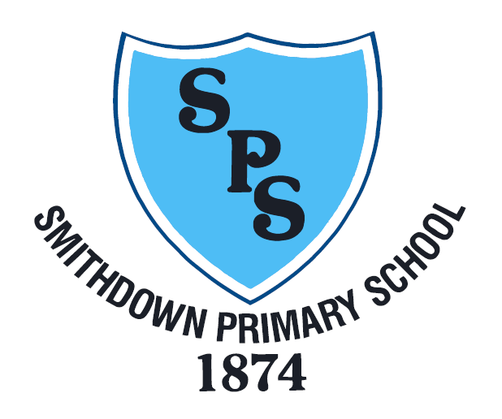

Outbreak Management Plan

Smithdown Primary School

Adopted: September 2021

Table of Contents
Introduction 3
Roles and responsibilities 3
Risk Assessment 3
Contingency planning 4
When settings should consider extra action 4
Close mixing 5
Reporting a confirmed case 6
Testing 7
Face coverings 8
Shielding 9
Attendance restrictions 10
Educational Visits 11
Other restrictions: 11

Introduction
The Government has made it a national priority that education and childcare settings should continue to operate as normally as possible during the COVID-19 pandemic.
Measures affecting education and childcare may be necessary in some circumstances, for example:
- to help manage a COVID-19 outbreak within a setting
- as part of a package of measures responding to a Variant of Concern (VoC) or to extremely high prevalence of COVID-19 in the community
- to prevent unsustainable pressure on the NHS
This Outbreak Management Plan describes how we would operate if we were advised to reintroduce any measures described in the Contingency Framework: education and childcare settings.
This should be completed and in place before term starts so schools can quickly mobilise contingent measures. The Outbreak Management Plan should be regularly reviewed to keep up to date. Schools are advised to have this as part of their School Emergency Management Plan.

Roles and responsibilities
Local authorities, Director of Public Health and Health Protection Teams are responsible for managing localised outbreaks. They play an important role in providing support and advice to education and childcare settings.
Local authorities, Director of Public Health and Health Protection Teams can work with their regional partnership teams (RPTs) to escalate issues from the local level into the central Local Action Committee command structure. RPTs support local areas in managing outbreaks and provide advice and insights from across the country to the Chief Medical Officer and the Secretary of State for Health and Social Care to inform decision making.
Through the Local Action Committee command structure, ministers consider and take decisions on measures on an area-by-area basis in light of all available evidence, public health advice and the local and national context.
In rare circumstances, it may be necessary to escalate issues to ministers through other central government committees (for example incident management teams), but this should be by exception only.
Liverpool schools should have in place a Covid-19 lead who oversees a response team in the case of an outbreak. In addition to the Covid-19 other staff may be involved in different elements of the outbreak management plan.

Risk Assessment

Our school risk assessment can be found here:

https://smithdownprimary.com/

Our risk assessment has been developed in line with national guidance and local advice. We have consulted with staff, unions and our governing body in order to apply national guidance and local advice to our setting.
Our risk assessment will be reviewed fortnightly in the first instance or if there are any incidents, near misses or changes to procedure.

In the case of any outbreak, schools should revisit their risk assessment to ensure that controls are being followed effectively, particularly
- Ensuring good hygiene for everyone
- Maintaining appropriate cleaning regimes
- Ventilation
- Following public heath advice on testing, self-isolation and managing confirmed cases of covid-19

Contingency planning
A good plan should cover:
- roles and responsibilities
- when and how to seek public health advice
- details on the types of control measures you might be asked to put in place (described in measures that settings should plan for and your sector’s guidance)
For each control measure you should include:
- actions you would take to put it in place quickly.
- how you would ensure every child, pupil or student receives the quantity and quality of education and support to which they are normally entitled.
- how you would communicate changes to children, pupils, students, parents, carers and staff.

If extra action is needed, this will be advised by the Director of Public Health or the Local Health Protection Team.

The Director of Public Health or Health Protection Team may give schools advice reflecting the local situation. In areas where rates are high, this may include advice that local circumstances mean that the thresholds for extra action can be higher than set out above.

When settings should consider extra action
For most education and childcare settings, whichever of these thresholds is reached first:
- 5 children or staff, who are likely to have mixed closely, test positive for COVID-19 within a 10-day period; or
- 10% of children or staff who are likely to have mixed closely test positive for COVID-19 within a 10-day period in the whole school community
Liverpool Public Health will regularly review local data including number of positive cases, testing uptake, testing positivity and local hospital admissions. This data will influence threshold levels for additional action.
All positive cases will continue to be reported to the local authority via the online MDS form https://www.smartsurvey.co.uk/s/covid-19-schools/
Public Health and School Improvement Liverpool will liaise with schools when there are concerns about an outbreak in a school setting.

Close mixing
Identifying a group that is likely to have mixed closely will be different for each setting. Below are some examples.
For schools, this could include:
  - a form group or subject class
  - a friendship group mixing at breaktimes
  - a sports team
  - a group in an after-school activity

Reporting a confirmed case

For COVID-19 queries related to educational settings – Single Point of Contact (SPOC)

School Improvement Liverpool | SPOC@si.liverpool.gov.uk  0151 233 3901
Notifying a confirmed case

All confirmed cases should be notified via the online MDS form below:

www.smartsurvey.co.uk/s/covid-19-schools/

DfE helpline
Telephone: 0370 000 2288
Monday to Friday, 9am to 5pm

School Covid-19 Lead Details
Primary Contact
Name: | Philip Horne
Telephone Number: | 0151 709 6229
Out of Hours Telephone Number: |  | 0151 709 6229  deputyhead@smithdown.liverpool.sch.uk
Secondary Contact
Name: | Lorna Dickson
Telephone Number: | 0151 709 6229
Out of Hours Telephone Number: |  | 0151 709 6229  deputyhead@smithdown.liverpool.sch.uk

Reintroducing bubbles / reduce mixing between groups

Lead Person: |  | Key contacts:
Philip Horne |  | SPOC@si.liverpool.gov.uk
Communications:
Consider communications to parents about changes to the school day such as:
- staggered start / finish
- impact on lessons
Additional Information:
Communication to parents via letter, twitter and school website
Please see RA
Considerations:
Organisation | How will this impact:  - dining arrangements  - playtime  - lessons  - intervention groups  - staffing  - space  - extra curricula activities  - movement through school
Resources | Additional staffing other resources already in use
Other: | Parents can be phoned directly by staff when required

Shielding

Lead Person: |  | Key contacts:
Philip Horne |  | Supply cover: supply@si.liverpool.gov.uk  Agencies school use  School HR team:
Communications:
Individuals who are advised to shield should be contacted directly by government, local authority or GP

Additional Information:
Please see RA
Considerations:
Business continuity: | The school has relevant and appropriate resources in place to cover shielding staff when the need arises
Staff impacted | Agreed cover in place
Cover | Agency and in house cover would be used
Other:

Attendance restrictions

Lead Person: |  | Key contacts:
Lorna Dickson (supported by MGL) |  | Remote education – paul.bradshaw@si.liverpool.gov.uk;
Communications:
Communication to parents via letter, twitter, school website and telephone calls
Please see RA
Additional Information:
https://get-help-with-remote-education.education.gov.uk/statutory-obligations.html

https://www.gov.uk/government/publications/covid-19-free-school-meals-guidance/covid-19-free-school-meals-guidance-for-schools
Considerations:
Access to computers and internet | Children and families already identified who may need a device for remote learning.  Parents aware that they contact school for support
Free School Meals: | Wonde (managed by Business Manager)
Key Worker and Vulnerable Children: | Vulnerable and key worker children identified by SLT in consultation with families.
Safeguarding provision: | Safe guarding processes in place to support families and children if isolating. Please see website for further information
Other:

Educational Visits

Lead Person: |  | Key contacts:
Lorna Dickson and Katie Ridley |  | Educational Visits: Nicola.horton@si.liverpool.gov.uk
Communications:
Communication to parents via letter, twitter, school website and telephone calls
Please see RA
Additional Information:
Outdoor Education Advisors Panel: www.oeap.ng
https://www.gov.uk/government/publications/health-and-safety-on-educational-visits/health-and-safety-on-educational-visits
Considerations:
Cost implications: | School will always obtain best value for money for school trips and all trips will be to enhance our curriculum offer. Subsidy to support families where possible
Risk Assessment | All RA updated in conjunction with external Building Clerk of Works
Other: | School will always liaise with external businesses to see if open to school trips before booking and work in conjunction with their own covid measures put in place

Other restrictions:
If the Director of Public Health or Health protection team advise additional measures, they may also advise restrictions on the activities below. If this is the case, then please consider
- open days
- transport
- transition or taster days
- parental attendance in settings
- live performances in settings

