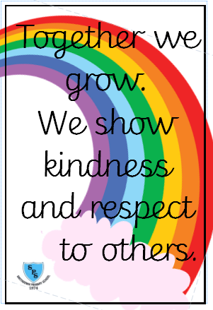****

**Number and place value**

Pupils should be taught to:

* read, write, order and compare numbers to at least 1 000 000 and determine the value of each digit
* count forwards or backwards in steps of powers of 10 for any given number up to 1 000 000
* interpret negative numbers in context, count forwards and backwards with positive and negative whole numbers through zero
* round any number up to 1 000 000 to the nearest 10, 100, 1000, 10 000 and 100 000
* solve number problems and practical problems that involve all of the above
* read Roman numerals to 1000 (M) and recognise years written in Roman numerals.

**Addition and subtraction; Multiplication and division**

Pupils should be taught to:

* add and subtract whole numbers with more than 4 digits, including using formal written methods (columnar addition and subtraction)
* add and subtract numbers mentally with increasingly large numbers
* use rounding to check answers to calculations and determine, in the context of a problem, levels of accuracy
* solve addition and subtraction multi-step problems in contexts, deciding which operations and methods to use and why.

**We have one school rule for pupils, staff, parents and visitors.**

**Maths**

**English**

**Henry’s Freedom Box by Ellen Levine**

* Diary
* Biography

**FArTHER by Grahame Baker-Smith**

* Setting Description
* Letter

**Useful Information**PE days: 5NA will have PE every Monday and 5TS will have PE every Tuesday.   
Homework: Children will receive spellings and homework on google classroom every Friday. There will be a spelling test every Friday too.

Class twitter: @SmithdownPrimY5

School Website: <https://smithdownprimary.com/>

**Staff**

Teachers: Miss Allt and Mr Smith

Learning Support Assistants: Mrs Venables and Miss Phillips

**Welcome message**

Dear children and families,

We hope you have had a lovely summer holiday and had time to relax and have lots of fun!

We are really looking forward to welcoming you back to school as our new Year 5’s! We can’t wait to teach you lots of new things and to have lots of fun along the way.

The Year 5 team.

Autumn Term 1 Curriculum Overview for Year 1



**Animals including humans**

Pupils will learn about life cycles of various species – including mammals, amphibians and birds. They will also be able to describe the different reproduction processes of plants.

NC links

* Describe the differences in the life cycles of a mammal, an amphibian, an insect and a bird.
* Describe the life process of reproduction in some plants and animals

**Properties and Changes of materials**

* compare and group together everyday materials on the basis of their properties, including their hardness, solubility, transparency, conductivity (electrical and thermal), and response to magnets
* know that some materials will dissolve in liquid to form a solution, and describe how to recover a substance from a solution
* use knowledge of solids, liquids and gases to decide how mixtures might be separated, including through filtering, sieving and evaporating
* give reasons, based on evidence from comparative and fair tests, for the particular uses of everyday materials, including metals, wood and plastic
* demonstrate that dissolving, mixing and changes of state are reversible changes

Together we Grow

**Science**



**Website design / Body Percussion**

**Computing /Music**

**What is a computer?**

Digital literacy and IT

**Art /DT**

LS Lowry - Pupils will learn and practice a range of skills using charcoal and different pencil grades.

Food Tech - Understand and apply the principles of a healthy and varied diet. Understand seasonality, and know where and how a variety of ingredients are grown, reared, caught and processed.

Hockey and Gymnastics

**History**

**WW2-** Children will learn why World War II started and which countries were involved. Pupils will find out why children were evacuated and where they were sent. Pupils will research the impact that WWII had on our local area.

**Being Me in My World and Celebrating Difference**

**PHSE**

**PE**

**Special People**

What makes people special?

*Christianity, Judaism*

**We will be thinking about the question –**

Why do some people think that God exists?

**RE**