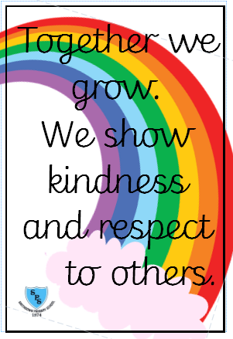****

**Communication and Language**

**Developing children’s skills to listen to one another and respond using gestures and picture clues.**

**Developing children’s confidence to talk to others**

**Beginning to extend vocabulary.**

**Sharing stories and learning new words**

**Retelling events from story and real life.**

**Developing early language skills in real life contexts- eg dinner times, snack times.**

**We have one school rule for pupils, staff, parents and visitors.**

**Welcome message**

**A very warm welcome to Reception from all of the staff. We are really looking forward to helping the children settle into school life and ensuring that they have a high quality early years’ experience.**

**We are looking forward to building relationships with our families through parental workshops, stay and play sessions and coffee mornings as we value our partnerships with families in Reception.**

**Useful Information**

PE days: RAG- Thursday and RLMc- Friday

Homework: Weekly on Fridays on Seesaw

Class twitter: @SmithdownPrimR

School Website: <https://smithdownprimary.com/>

**Personal, Social and Emotional Development**

**Supporting children to settle into their new environment.**

**Ensuring children can access all areas of the provision confidently.**

**Modelling kind behaviour- Playing a range of circle games indoors and outdoors.**

**Building relationships with staff and peers.**

**Establishing behavioural expectations and supporting children with routines.**

**Establishing friendships with others.**

**Supporting children at dinner times with food choices**

**rting children to settle into their new environment.**

**Ensuring children can access all areas of the provision confidently.**

**Modelling kind behaviour- Playing a range of circle games indoors and outdoors.**

**Building relationships with staff and peers.**

**Establishing behavioural expectations and supporting children with routines.**

**Establishing friendships with others.**

**Supporting children at dinner times with food choices**

Autumn Term 1 Curriculum Overview for Reception

**Staff**

Teachers: Miss Guy (RAG) and Miss McFarlane (RLMc)

Learning Support Assistants: Miss Losh and Miss McKenna (RAG) Miss Jones and Miss Wilson (RLMc) Mrs Cawthorne- Early Years Interventions



**Physical Development**

**Engaging in activities such as the beans game that encourage children to explore different ways of moving.  
Using scissors and malleable materials with growing independence  
Walking up and down stairs with one foot to each stair.  
Holding pencil with two fingers and thumb and using it with control.  
Begins to form recognisable letters.  
Going to toilet independently and washing / drying hands  
Dressing and undressing for PE**

Together we Grow



**Expressive Arts and Design**

**Children to use a range of materials indoors and outdoors to develop creativity by making a range of imaginative art pieces eg self- portraits, home box models, birthday balloons and family collages**

**Understanding the World-**

**Talking about our families/ special people in our lives/ drawing pictures of familiar people**

**Creating homes using a selection of materials**

**Maths**

**Counting a small group of objects with 1:1 correspondence.**

**Matching numerals to amounts.**

**Sharing a selection of simple number songs using props**

**Literacy**

**Sharing a selection of fiction stories based on ourselves and families –You Choose, The Tiger Who Came to Tea, and the Large Family stories/ birthday story for Teddy’s birthday**

**Encourage children to give meaning to their marks when drawing or painting, e.g. when drawing a picture ask to talk about it and add labels such as ‘Mum’ or ‘car’ using own marks.**

**Practicing name writing**