Year Group: EYFS Nursery Term: Autumn 1
Theme: Amazing me/friendships P.O.R text: We’re Going on a Bear Hunt
 | Week 1  W/b 7.9.20 | Week 2  W/b 14.9.20 | Week 3  W/b 21.9.20 | Week 4  W/b 29.9.20 | Week 5  W/b 5.10.20 | Week 6  W/b 12.10.20 | Week 7  W/b 19.10.20
PSED | Recognising Friends  Play roll the ball game. | The Colour monster.  How do different colours make us feel? | Expressing feelings during circle time through thumbs up and thumbs down. | Introduce Roar rainbow. | How does the bear feel at the end of the story?  Fruit salad game. | Being responsible  Play the Jelly baby game. | Describing and acting out different emotions.
Communication and Language | Nursery  Rhymes  Turn taking – choosing & singing rhymes from the bag. | Talking together board – Use picture prompts to support and develop language. | Joining in with repeated refrains and anticipating key events. | Walking through sensory trays – describing what they can feel. | Re tell the story using the climbing frame outside to go over/under the river/grass etc | Make log pile houses and talk through what they are doing. Who is going tolive in there? | Making sensory bottles and listening to matching sounds.
Physical Development | Managing own lunch and feeding self. | Dough Disco to Nursery Rhymes. | Moving like different animals. | Make bear face sandwiches. | Drawing under and on top of tables. | Use brown playdough and purple pipe cleaners to make The Gruffalo | Move like the different animals in the story.
Literacy | Drawing a picture of themselves. | Nursery  Rhymes  Painting their favourite character.  T4W – Wheels on the bus. | Dear Zoo  Painting which pet they would like from the zoo. | We’re Going on a Bear Hunt  Retelling the story using actions. | We’re Going on a Bear Hunt  Mark making bears features. | The Gruffalo  Floor mark making scenes from the text. | The Gruffalo  Drawing their own terrible creature.
Maths | Counting objects in play.  e.g cars, passing 2 bananas in the home corner. | I spy a colour – colour hunts | 5 little monkeys song  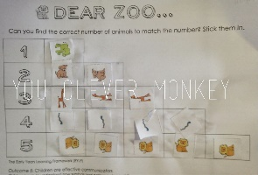 | Compare bears and numicon in the water tray.  Matching and counting bears. | 2d shape hunt and song. | Counting purple prickles on the gruffalo’s back. | Ordering sticks and discussing length.
Knowledge and Understanding of the World | Role play in the kitchen and resources. | Tiny Tim tuff spot tray  Investigate making bubbles. | Wrapping toys for presents and reinact the book. | Creating a large Bear collage. | Make binoculars to go on a bear hunt. | Make Gruffalo crumble. | Matching key animals from the text and the foods that they eat.
Expressive Art and Design | Exploring the different noises of instruments.  Handprints | Creating a collage rainbow.  Making colour jars/monsters. | Making own play dough.  Painting to different types of music. | Make paper plate bear faces. | Compare bears in gloop – discuss texture/count the bears etc | 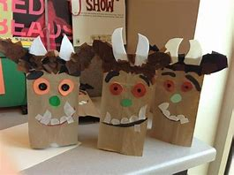  Paper bag gruffalos | 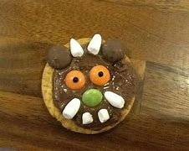  Make Gruffalo biscuits
R.E  SMSC  Links | Discovery R.E | Discovery RE | Discovery RE | Discovery RE | Discovery RE | Discovery RE | Discovery RE
PSHE | Jigsaw Scheme | Jigsaw Scheme | Jigsaw Scheme | Jigsaw Scheme | Jigsaw Scheme | Jigsaw Scheme | Jigsaw Scheme

