Track and Trace
All visitors to school will be asked to fill in the following track and trace form:
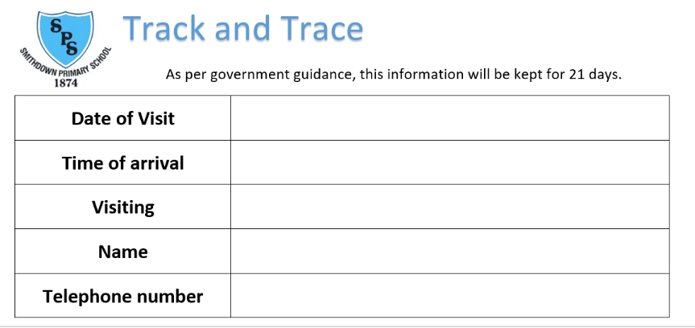

As a school we will adhere to the following government guidance regarding the storage of this information:
https://www.gov.uk/guidance/maintaining-records-of-staff-customers-and-visitors-to-support-nhs-test-and-trace
How records will be maintained
To support NHS Test and Trace, we will hold records for 21 days. This reflects the incubation period for COVID-19 (which can be up to 14 days) and an additional 7 days to allow time for testing and tracing. After 21 days, this information will be securely disposed of via shredding.
All collected data will comply with the General Data Protection Regulation and will not be kept for longer than is necessary.
General data protection regulation (GDPR)
The data that we collect is personal data and will be handled in accordance with GDPR to protect the privacy of staff, customers and visitors
When information will be shared with NHS Test and Trace
NHS Test and Trace will ask for these records only where it is necessary. For example, if our school s has been identified as the location of a potential COVID-19 outbreak.
NHS Test and Trace will work with us to ensure that information is shared in a safe and secure way.
NHS Test and Trace will handle all data according to the highest ethical and security standards and ensure it is used only for the purposes of protecting public health, including minimising the transmission of COVID-19.

If you are contacted by NHS Test and Trace
Contact tracers will:
- call you from 0300 013 5000
- send you text messages from ‘NHStracing’
- ask you to sign into the NHS Test and Trace contact-tracing website
Contact tracers will never:
- ask you to dial a premium rate number to speak to them (for example, those starting 09 or 087)
- ask you to make any form of payment or purchase a product or any kind
- ask for any details about your bank account
- ask for your social media identities or login details, or those of your contacts
- ask you for any passwords or PINs, or ask you to set up any passwords or PINs over the phone
- disclose any of your personal or medical information to your contacts
- ask about protected characteristics that are irrelevant to the needs of test and trace
- provide medical advice on the treatment of any potential coronavirus symptoms
- ask you to download any software to your PC or ask you to hand over control of your PC, smartphone or tablet to anyone else
- ask you to access any website that does not belong to the government or NHS

Please do not hesitate to contact the school or ask a member of staff if you have any further questions relating to our Track and Trace system.

