**Computing:**

* use logical reasoning to explain how some simple algorithms work and to detect and correct errors in algorithms and programs
* use technology safely, respectfully and responsibly

**Year 3 Autumn 2019**

**History: The World Museum Online Workshop**

**Phil Harris – A day in Ancient Egypt**

The achievements of the earliest civilizations – an overview of where and when the first civilizations appeared and a depth study of Ancient Egypt

**Music:**

* Appreciate and understand a wide range of high-quality live and recorded music drawn from different traditions and from great composers
* Develop an understanding of the history of music

**Geography:**

* name and locate counties and cities of the United Kingdom, geographical regions and their identifying human and physical characteristics, key topographical features (including hills, mountains, coasts and rivers)
* Practice geographical skills through using maps, atlases, globes and digital/computer mapping to locate features studied
* understand geographical similarities and differences through the study of human and physical geography of a region of the United Kingdom, a region in a European country
* Use 8 points of a compass/OS maps and symbols to build knowledge of the UK

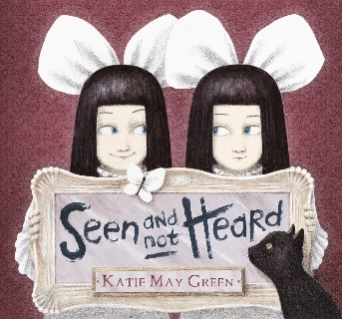

**P.E.:**

* Experience, rehearse and perform a range of dance from around the world
* Develop an understanding of the origins of dance
* Learn to count in beats matching movements to rhythm

**Science:**

* compare how things move on different surfaces
* notice that some forces need contact between two objects, but magnetic forces can act at a distance
* observe how magnets attract or repel each other and attract some materials and not others
* compare and group together a variety of everyday materials on the basis of whether they are attracted to a magnet, and identify some magnetic materials
* describe magnets as having two poles predict whether two magnets will attract or repel each other, depending on which poles are facing

**Art/Design Technology: Keith Haring Virtual Tour**

* To create a sculpture using clay
* To use levers to create work in the style of Keith Haring