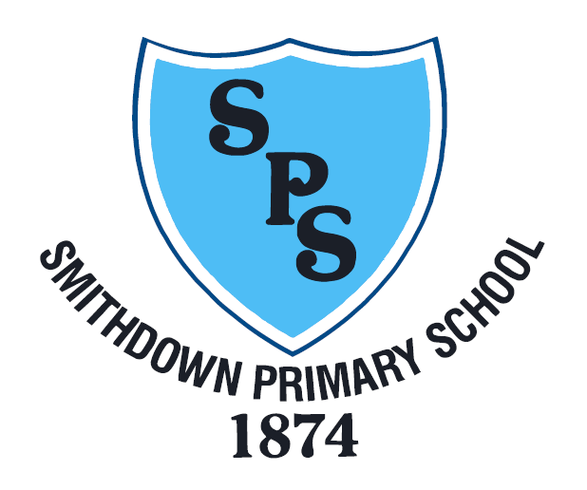

Smithdown Primary School Privacy Notice

Adopted: May 2018
Review date: May 2019
Reviewed: November 2019
Smithdown Primary Privacy Notice (How we use pupil information)

The categories of pupil information that we collect, process, hold and share include:

- personal identifiers and contacts (such as name, unique pupil number, contact details and address)
- characteristics (such as ethnicity, language, and free school meal eligibility)
- safeguarding information (such as court orders and professional involvement)
- special educational needs (including the needs and ranking)
- medical and administration (such as doctors information, child health, dental health, allergies, medication and dietary requirements)
- attendance (such as sessions attended, number of absences, absence reasons and any previous schools attended)
- assessment and attainment (such as EYFS, key stage , key stage 2 and phonics results,)
- behavioural information (such as exclusions and any relevant alternative provision put in place)

Why we collect and use pupil information
We collect and use pupil information, for the following purposes:
- to support pupil learning
- to monitor and report on pupil attainment progress
- to provide appropriate pastoral care
- to assess the quality of our services
- to keep children safe (food allergies, or emergency contact details)
- to meet the statutory duties placed upon us for DfE data collections

Under the General Data Protection Regulation (GDPR), the lawful bases we rely on for processing pupil information are:
We collect and use pupil information under Article 6 of EU General Data Protection Regulations (GDPR) to ensure the school carries out its duties lawfully and appropriately.
Data is required:
- for compliance with our legal obligations (6c)
- for the necessary purpose of our duties as a school (6f)
Consent will be required and requested using our Home / School Agreement.
We also collect and use pupil data under Article 9 of EU GDPR for data collection purposes which is required under the Education Act 1996, such as the child’s racial or ethnic origin, and religious beliefs.

How we collect pupil information
Pupil data is essential for the schools’ operational use. Whilst the majority of pupil information you provide to us is mandatory, some of it requested on a voluntary basis. In order to comply with the data protection legislation, we will inform you at the point of collection, whether you are required to provide certain pupil information to us or if you have a choice in this.

How we store pupil data
We follow the Liverpool Authority guidelines for the length of time that information is held by school: https://liverpool.gov.uk/schools-and-learning/requests-for-pupil-records/

Who we share pupil information with
We routinely share pupil information with:

- schools that the pupils attend after leaving us
- our local authority
- health services (such as school nurse, hospitals, etc.)
- educational support (such as educational psychologists or
- the Department for Education (DfE)

Why we regularly share pupil information
We do not share information about our pupils with anyone without consent unless the law and our policies allow us to do so. We share pupils’ data with the Department for Education (DfE) on a statutory basis.
We are required to share information about our pupils with the DfE under regulation 5 of the Education (Information About Individual Pupils) (England) Regulations 2013.

How Government uses your data
The pupil data that we lawfully share with the DfE through data collections:
- underpins school funding, which is calculated based upon the numbers of children and their characteristics in each school.
- informs ‘short term’ education policy monitoring and school accountability and intervention (for example, school GCSE results or Pupil Progress measures).
- supports ‘longer term’ research and monitoring of educational policy (for example how certain subject choices go on to affect education or earnings beyond school)

Data collection requirements
To find out more about the data collection requirements placed on us by the Department for Education (for example; via the school census) go to https://www.gov.uk/education/data-collection-and-censuses-for-schools

The National Pupil Database (NPD)
Much of the data about pupils in England goes on to be held in the National Pupil Database (NPD).
The NPD is owned and managed by the Department for Education and contains information about pupils in schools in England. It provides invaluable evidence on educational performance to inform independent research, as well as studies commissioned by the Department.
It is held in electronic format for statistical purposes. This information is securely collected from a range of sources including schools, local authorities and awarding bodies.
To find out more about the NPD, go to https://www.gov.uk/government/publications/national-pupil-database-user-guide-and-supporting-information

Sharing by the Department
The law allows the Department to share pupils’ personal data with certain third parties, including:
- schools
- local authorities
- researchers
- organisations connected with promoting the education or wellbeing of children in England
- other government departments and agencies
- organisations fighting or identifying crime
For more information about the Department’s NPD data sharing process, please visit:
https://www.gov.uk/data-protection-how-we-collect-and-share-research-data

Requesting access to your personal data
Under data protection legislation, parents and pupils have the right to request access to information about them that we hold.

You also have the right to:
- object to processing of personal data that is likely to cause, or is causing, damage or distress
- prevent processing for the purpose of direct marketing
- object to decisions being taken by automated means
- in certain circumstances, have inaccurate personal data rectified, blocked, erased or destroyed; and
- a right to seek redress, either through the ICO, or through the courts

If you have a concern or complaint about the way we are collecting or using your personal data, you should raise your concern with us in the first instance or directly to the Information Commissioner’s Office at https://ico.org.uk/concerns/

Contact
To make a request for your personal information, or be given access to your child’s educational record, contact:

Mrs L Dickson (Deputy Head Teacher) on 0151 709 6229 or
Smithdown-ao@smithdown.liverpool.sch.uk

