‘Together We Grow’

Smithdown Primary School
Child and Parent/Carer Health and Wellbeing Policy

Adopted: October 2019

‘Together We Grow’

Our Key Values
Our school motto is ‘Together we Grow’, Courage, Friendship, Equality, Respect and Thoughtfulness
We ensure that every child has access to a broad, balanced and supportive curriculum. Through this we are able to give our pupils a range of opportunities and experiences to grow and develop academically, physically socially and morally.

Our School Vision
At Smithdown Primary School we aim high. We want every part of our school community- pupils, parents and members of staff to experience success. Smithdown Primary School will work with everyone to create a happy, safe and stimulating setting where children are motivated to learn together. By maintaining high expectations of ourselves and each other, our children will be equipped to encounter opportunities and challenges with resilience and determination. We encourage a curiosity about the world and strive to ensure that our children will contribute positively, now and in the future.

Taking care of our Mental Health

We all need to take care of our mental health and wellbeing whether we have a mental health problem or not.
Mental wellbeing describes how you are feeling and how well you can cope with day-to-day life. It can change from moment to moment, day to day, month to month.

- Policy Purpose

This purpose of this policy is to ensure that we, as a school community embrace the many school practices that support children and parents health and wellbeing

It shows some of the ways in which we commit to maintaining wellbeing and it recognises that each family and their circumstances are different but provides an overview of the basis on which everyone can contribute, and expect to be treated.

We aim to nurture and develop our children’s wellbeing and selfworth, with a view to enabling them in the long term to participate in the wider community; laying the foundations for their teenage years and adult life.

2.Working with our children

In order to support children, Smithdown will:

Pupil Wellbeing | Approaches
As a whole school | - PSHE curriculum including circle time  - Huge Bag of Worries  - ‘Together We Grow’ ethos encourages supporting one another and growing academically, emotionally, socially.  - Staff Training  - Teaching and Learning approaches  - Pupil voice  - School Council  - Open door policy for Family Mentor  - Playground buddies  - After School Clubs (free)  - Breakfast Club (minimal charge)  - Assemblies  - Family days (Winter Wonderland, Summer events)  - We provide opportunities for your parents/carers to come into school.  - We entwine key message of resilience, wellbeing and health for all learners through our curriculum.
Targeted Support (how we help you specifically) | One to One counselling with Family Mentor  Think Yourself Great  On Site Play Therapists  Langauge Support and nurture groups

3.Working with our parents/carers
In order to support our parents and carers, Smithdown will:
Parent/Carer Wellbeing | Approaches
As a school we will | - ‘Together We Grow’ ethos encourages supporting one another and growing academically, emotionally, socially.  - Newletters  - Open door Policy  - EHATS  - Graded Care trained staff  - Home visits  - 3 Mental Health First Aiders  - Open door policy for Family Mentor  - Highlight sources of information and support on our school website.  - Make our mental health policy easily accessible to parents.  - Share ideas about how parents can support positive mental health in their children and themselves through our regular review meetings.  - Parental courses (ESOL etc)  - Stay and Play Toddler sessions  - Families Connect  - Signposting to external support agencies

4. Smithdown Mental Health First Aiders

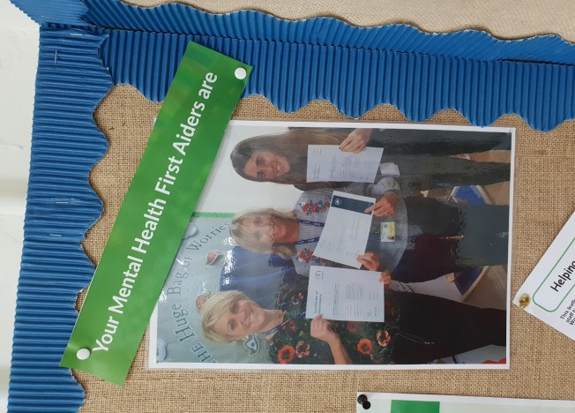
Mrs.l.Worthington
Mrs.J.Ireland
Ms.N.Garvey
Links to Useful Websites
www.nhs.uk/oneyou/every-mind-matters/
www.mentallyhealthyschools.org.uk

Confidentiality
School cannot promise confidentiality if we feel a child or parent is at risk from harm and Smithdown will follow their Safeguarding Procedures.

