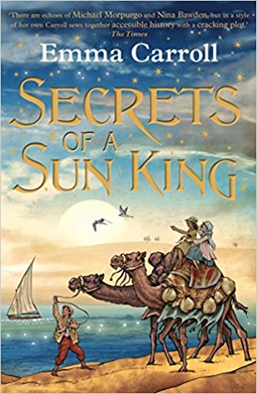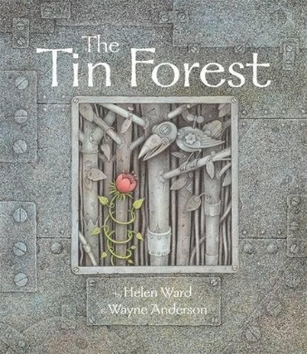

**Year 3 Autumn 2018  
POR: Tin Forest/Secrets of a Sun King  
National Curriculum Links**

**Art/Design Technology:**

* to create sketch books to record their observations and use them to review and revisit ideas
* to improve their mastery of art and design techniques, including drawing, painting and sculpture with a range of materials [for example, pencil, charcoal, paint, clay]
* about great artists, architects and designers in history

**Music:**

* Appreciate and understand a wide range of high-quality live and recorded music drawn from different traditions and from great composers
* Develop an understanding of the history of music

**Computing:**

* use logical reasoning to explain how some simple algorithms work and to detect and correct errors in algorithms and programs
* use technology safely, respectfully and responsibly

**Geography:**

* name and locate counties and cities of the United Kingdom, geographical regions and their identifying human and physical characteristics, key topographical features (including hills, mountains, coasts and rivers)
* Practice geographical skills through using maps, atlases, globes and digital/computer mapping to locate features studied
* understand geographical similarities and differences through the study of human and physical geography of a region of the United Kingdom, a region in a European country
* Use 8 points of a compass/OS maps and symbols to build knowledge of the UK

**Science:**

* identify and describe the functions of different parts of flowering plants: roots, stem/trunk, leaves and flowers
* explore the requirements of plants for life and growth (air, light, water, nutrients from soil, and room to grow) and how they vary from plant to plant
* investigate the way in which water is transported within plants
* explore the part that flowers play in the life cycle of flowering plants, including pollination, seed formation and seed dispersal

**P.E.:**

* Experience, rehearse and perform a range of dance from around the world
* Develop an understanding of the origins of dance
* Learn to count in beats matching movements to rhythm

**History:**

* the achievements of the earliest civilizations – an overview of where and when the first civilizations appeared and a depth study of Ancient Egypt

**Year 3 Autumn Term 2018  
Tin Forest/Secrets of a Sun King  
Activities/Outcomes**

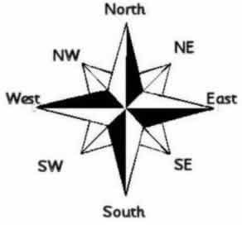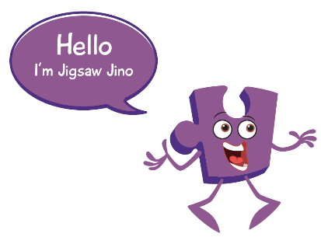

**WOW DAY:**

Horrible Histories Performance Visit linked to Ancient Egypt study @ end of Aut1

**Science:**

* Children to investigate the functions of plants (building on Y1 knowledge) through drama and art tools
* Scientifically investigating how water is transported through plants by completing an observation over time
* Discovering how flowers are pollinated through learning about the reproductive parts of a flower – dissecting.
* Understanding how flowers are pollinated by creating a stope-frame animation using play-dough/storyboard features
* Explain how seeds are dispersed through drama

|  |  |
| --- | --- |
| **Religious Education:**  Would celebrating Divali at home and in the  community bring a feeling of belonging to a  Hindu child?   |  | | --- | | Does participating in worship help people to  feel closer to God or their faith community?   We will be investigating what happens during the  festival of Divali and whether the celebrations bring  a sense of belonging to Hindus | |

**Music:**

* Taught by external service from RESONATE

**PSHE:**

|  |  |  |  |  |  |
| --- | --- | --- | --- | --- | --- |
| * I recognise my worth and can identify positive  things about myself and my achievements.  |  |  |  |  | | --- | --- | --- | --- | | * I can set personal goals * I can face new challenges positively, make  responsible choices and ask for help when I  need it  |  |  |  | | --- | --- | --- | | * I understand why rules are needed and how  they relate to rights and responsibilities  |  |  | | --- | --- | | * I understand that my actions affect myself  and others and I care about other people’s feelings  |  | | --- | | * I understand my actions affect others and try to see things from their points of view | | | | |  | |

**Computing:**

* Identify algorithms, decompose a set of instructions and debug code to achieve a given criteria
* Evaluate advantages/disadvantages of the Internet as a communication tool. Produce a written argument

**Art:**

* Artist study; Henri Rousseau. Observing different techniques of oil paintings
* Evaluating artist work and style and imitating their own

**Geography:**

* Locational Geography beginning from our surroundings, looking at addresses and using a range of maps/google earth/atlas to view our location
* Understanding counties in England/compass points of the UK
* Comparing UK to a country from Europe (Spain)

**P.E.:**

* Children to experience a form of dance from somewhere around the world each week during additional 1 hour P.E. session.
* Children to research about roots of dancing from around the world
* Children to use Maths of counting in 4’s and 8’s to rehearse beats.

Maths

* count from 0 in multiples of 4, 8, 50 and 100; find 10 or 100 more or less than a given number
* recognise the place value of each digit in a 3-digit number (100s, 10s, 1s)
* compare and order numbers up to 1,000
* identify, represent and estimate numbers using different representations
* read and write numbers up to 1,000 in numerals and in words
* solve number problems and practical problems involving these ideas
* add and subtract numbers mentally, including:
  + a three-digit number and 1s
  + a three-digit number and 10s
  + a three-digit number and 100s
* add and subtract numbers with up to 3 digits, using formal written methods of columnar addition and subtraction
* estimate the answer to a calculation and use inverse operations to check answers
* solve problems, including missing number problems, using number facts, place value, and more complex addition and subtraction

English

* develop positive attitudes to reading, and an understanding of what they read, by:
* listening to and discussing a wide range of fiction, poetry, plays, non-fiction and reference books or textbooks
* reading books that are structured in different ways and reading for a range of purposes
* using dictionaries to check the meaning of words that they have read
* increasing their familiarity with a wide range of books, including fairy stories, myths and legends, and retelling some of these orally
* identifying themes and conventions in a wide range of books
* understand what they read, in books they can read independently, by:
* checking that the text makes sense to them, discussing their understanding, and explaining the meaning of words in context
* asking questions to improve their understanding of a text
* drawing inferences such as inferring characters’ feelings, thoughts and motives from their actions, and justifying inferences with evidence
* predicting what might happen from details stated and implied
* identifying main ideas drawn from more than 1 paragraph and summarising these
* identifying how language, structure, and presentation contribute to meaning
* use further prefixes and suffixes and understand how to add them