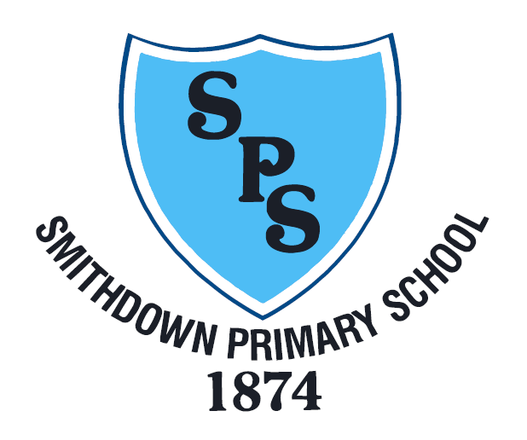

Smithdown Primary School

School Cleaner Information Pack

October 2018

Contents:

- Letter from Head Teacher

- Job Description

- Person Specification

- Advert

- How to Apply

Letter from Head Teacher

Dear Applicant

I hope that having read the job and person specifications below and after visiting our school website, you will make the decision to apply for the post of Cleaner at Smithdown Primary School.

We have wonderful team who always manages to do that something extra that makes Smithdown such a fabulous place for children to learn. We have high standards at Smithdown and achieve this through a creative and fun curriculum but also by providing an environment where children feel safe and happy.

The children are eager to learn and they bring out the best in their teachers. They are polite and courteous and these qualities are commented on by visitors to our school.

We are looking for an energetic and enthusiastic Cleaner who can contribute to the next phase in the school’s development. You will demonstrate high standards and show commitment and determination in the maintenance of the school premises. Working alongside myself, staff, pupils and Governors you will contribute towards our drive to be outstanding in all we do.

At Smithdown you will be given every opportunity to develop and enhance your skills, knowledge and experience of cleaning and the ethos of school life.

I am proud to be the Head Teacher at Smithdown Primary. Our children are wonderful, our staff are hardworking, our Governors are supportive and our parents want the best for their children.

You are welcome to come and visit our school. Please do not hesitate to contact me if you require any further information.

Yours sincerely

Mr P. Horne
Head Teacher

JOB DESCRIPTION

Job title: School Cleaner

The School cleaner will work as part of a team to perform a variety of regular and one-off cleaning tasks and duties as directed by their line manager.

Main Responsibilities:
- Be responsible for ensuring the cleanliness of your designated area and for maintaining high and consistent standards.
- Take initiative to perform cleaning and tidying tasks that are not specifically contained within the rota but require attention as part of maintaining overall high standards.
- Liaise with School Caretaker and Head teacher as required to ensure the cleaning rota operates smoothly around school.
- Report cleaning supplies requirements and stock levels to the line manager.
- Ensure Health & Safety, quality and general procedure compliance
- Work as part of a team and support other members of the cleaning team to meet standards and school objectives.
- Be punctual, reliable and trustworthy.
- To ensure that a high level of cleanliness is maintained throughout the school on a daily basis by using cleaning supplies and equipment appropriately.
- Be responsible for an area and will be expected to clean to the frequency and standards set out.
- To ensure standards and procedures are adhered to.
- All cleaners are required to contribute to major cleaning tasks during school holidays
- Empty and clean bins and remove waste to designated area, including the separation of waste, i.e. recycling.
- To contribute to major cleaning tasks during school holidays.
- Where practicable ensure windows and doors are closed and lights switched off.
- Report to Caretaker any defects seen which are likely to affect security i.e. broken/cracked window etc.
- To use electrical and mechanical equipment, floor polishers etc. after appropriate training.

Person Specification

Knowledge and Understanding:
- Some knowledge of Health & Safety Regulations as they relate to the operation of cleaning equipment and the dilution of cleaning materials.
- Good communication skills, both verbally and in writing.
- Able to meet deadlines and work to a tight schedule.
- Able to manage own work effectively.
- Safe working procedures with regard to chemicals and machinery.

Experience:
- Experience of undertaking a range of cleaning duties
- Working as part of a team and using own initiative.

Personal Attributes:
- Willingness to clean any area of the school as requested by the caretaker and Head teacher
- Willingness to take personal responsibility for standard of work carried out.
- Willingness to participate in further training and development opportunities offered by the school, to further knowledge.
- Willingness to maintain confidentiality on all school matters.
- Will need to be able to manage some heavy lifting.
- The successful candidate must be flexible with working hours, well organised and highly motivated.

Skills:
- Ability to work effectively and supportively as a member of the school team.
- Ability to work in an organised and methodical manner using own initiative.
- Ability to act on own initiative, dealing with any unexpected problems that arise.
- Ability to demonstrate commitment to Equal Opportunities.

Advert
Cleaner (Smithdown Primary School)
- Job Title: Cleaner
- Job Salary: Grade 1 £16,863 pro rata
- Permanent annualised contract
- 10 hours per week
- Work in school holidays will be required
About the school
Smithdown Primary School is a two form entry school in the heart of the Toxteth community. We share a site with Princes Primary School with whom we have an excellent relationship. We are a highly diverse school with a wonderful mix of children who are hardworking, well behaved and a delight to teach.
About the role
This is an exciting opportunity for an enthusiastic and outstanding practitioner to develop their skills within a highly supportive, creative and forward thinking school.
The successful candidate will:
    - Be dedicated to the success of children, colleagues, the School and themselves
    - Can successfully work effectively as part of a team
    - Work well under pressure
    - Have a ‘can do’ approach
    - Flexible, energetic, adaptable and has the ability to use initiative
    - Can prioritise and organise own work and the work of others
    - Communicates clearly
    - Have a commitment to personal professional development
    - Have excellent interpersonal skills
We can offer:
- Fabulous, proactive and supportive staff, governors and parents
- Lovely children who are eager to learn
- A commitment to your professional development

How to apply:
Use the supplication form available on the website www.smithdownprimary.com or contact the school on 0151 709 6229 or e mail smithdown-ao@smithdown.liverpool.sch.uk
Closing date: Friday 12th October
Short Listing date: Monday 15th October
Interview date: Wednesday 17th October

Smithdown Primary School values the diversity of its community and aims to have a workforce that reflects this. We therefore encourage applications from all sections of the community.
Smithdown Primary School is committed to safeguarding and promoting the welfare of children and young people and expects all staff and volunteers to share this commitment. All positions are subject to an enhanced DBS check and positive references.

