**Art and Design/Design and Technology**

*This half term, children will create their own junk model out of recyclable materials. (Linked to Geography topic and ‘The Tin Forest).*

**National Curriculum Links – Children will:**

Learn to improve their mastery of art and design techniques, including drawing, painting and sculpture with a range of materials

**Music** *Children will work take part in a weekly drumming workshop.*

**National Curriculum Links – Children will:**

* Play and perform in solo and ensemble contexts, playing musical instruments with increasing accuracy, fluency and control

**Geography***This half term, children will be asked the question: ‘Are We Damaging Our World.’*

**National Curriculum Links – Children will:**

* Describe and understand key aspects of thedistribution of natural resources including energy,minerals and water
* Use maps, atlases and globes to locate countries and describe features studied
* Use the eight points of a compass, symbols and keys to build their knowledge of the United Kingdom and the wider world
* Use fieldwork to observe, measure, record and present the human and physical features in the local area using a range of methods, including sketching maps, plans and graphs, and digital technologies.

**RE: Islam**

In this unit, children will learn about the things that are important to Muslims and how they can show commitment to God.

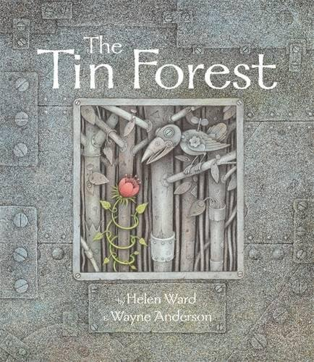

**Computing** *Children will learn recognise the importance of staying safe online during their Computing work.*

Children will also groups to create their own storyboard (linked to Geography Unit) and then use Book Creator and Brushes to create their own eBook including text, illustrations and audio

National Curriculum Links: Children will:

* Use technology safely, respectfully and responsibly; recognise acceptable/unacceptable behaviour; identify a range of ways to report concerns about content and contact
* select, use and combine a variety of software (including internet services) on a range of digital devices to design and create a range of programs, systems and content that accomplish given goals,

**PSHE: Being Me In My World**

In this unit, children will discuss goals for this year, as well as discussing how their own actions affect others and how they can make correct choices with regards to behaviour

**Science: Evolution and Inheritance (Stand-alone unit)**

*Children will learn about how the world has evolved from its beginnings to the present day, looking closely at the evolution of animals and humans*

**National Curriculum Links – Children will:**

* Recognise that living things have changed over time and that fossils provide information about living things that inhabited the Earth millions of years ago
* Recognise that living things produce offspring of the same kind, but normally offspring vary and are not identical to their parents
* Identify how animals and plants are adapted to suit their environment in different ways and that adaptation may lead to evolution

**PE** *Children will take part in weekly swimming sessions that will focus on developing strength, speed and agility in the water.*

*Children will also take part in weekly PE sessions based around Invasion Games*

**National Curriculum Links - Children will:**

* Swim competently, confidently and proficiently over a distance of at least 25 metres
* Use a range of strokes effectively [for example, front crawl, backstroke and breaststroke]
* Perform safe self-rescue in different water-based situations
* Play competitive games, modified where appropriate [for example, football, hockey and netball) and apply basic principles suitable for attacking and defending

**Mathematics** *This half term, children will work on their place value skills to embed knowledge of previously taught skills*

NC links:

* To read, write, order and compare numbers up to 10,000,000 and determine the value of each digit
* To round any whole number to a required degree of accuracy
* To use negative numbers in context, and calculate intervals across 0
* To solve number and practical problems that involve all of the above
* To multiply multi-digit numbers up to 4 digits by a two-digit whole number using the formal written method of long multiplication
* To divide numbers up to 4 digits by a two-digit whole number using the formal written method of long division, and interpret remainders as whole number remainders, fractions, or by rounding, as appropriate for the context
* To divide numbers up to 4 digits by a two-digit number using the formal written method of short division where appropriate, interpreting remainders according to the context
* To perform mental calculations, including with mixed operations and large numbers
* To identify common factors, common multiples and prime numbers
* To use their knowledge of the order of operations to carry out calculations involving the 4 operations
* To solve addition and subtraction multi-step problems in contexts, deciding which operations and methods to use and why
* To solve problems involving addition, subtraction, multiplication and division
* To use estimation to check answers to calculations and determine, in the context of a problem, an appropriate degree of accuracy

**English**

*This half term, our ‘Power of Reading’ book is ‘Frankenstein’*

*Written English work will be based around the text and will include a range of writing genres, including: Journal Writing, Newspaper Report Writing, letter writing, narrative writing*

**Reading**

**GPS (Grammar, Punctuation and Spelling)**

**NC links**

* Toread and discuss an increasingly wide range of fiction, poetry, plays, non-fiction and reference books or textbooks
* Read books that are structured in different ways and reading for a range of purposes
* Increase their familiarity with a wide range of books, including myths, legends and traditional stories, modern fiction, fiction and poetry from our literary heritage, and books from other cultures and traditions
* **(Grammar)** To work on different word classes – nouns, adjectives, verbs, adverbs, prepositions, determiners
* To ensure the consistent and correct use of tense throughout a piece of writing
* Ensure correct subject and verb agreement when using singular and plural
* **(Writing**) Identify the audience for and purpose of the writing
* In writing narratives, consider how authors have developed characters and settings in what pupils have read
* Assess the effectiveness of their own and others’ writing
* Propose changes to vocabulary, grammar and punctuation to enhance effects and clarify meaning
* **Punctuation** Begin to use the semi-colon, dash and colon to mark the boundary between independent clauses and to embed the use of commas to separate main and subordinate clauses within more complex sentences. Introduce use of brackets (for parentheses)
* **Spelling –** Children to work through Read Write Inc for Spelling, working through objectives as set out in the programme that reflects National Curriculum, e.g., words with endings with ent, ant, ency, ancy; soft c spellings

**Handwriting** Write legibly, fluently and with increasing speed

**PE**

•Children will have a swimming lesson each week to develop confidence in the water and developing an efficient stroke on front and back

•Children will learn about the importance of staying safe in the water and develop techniques that will help them to perform self-rescue in the water, e.g., treading water

**British Value links**

Understanding of different faiths and beliefs in the UK