**Year 3 Autumn 2 2017  
POR: The Dream-giver/Egyptian Cinderella  
National Curriculum Links**

**Music:**

* Appreciate and understand a wide range of high-quality live and recorded music drawn from different traditions and from great composers
* Develop an understanding of the history of music

**Art:**

* to improve their mastery of art and design techniques, including drawing, painting and sculpture with a range of materials
* learn about great artists, architects and designers in history.

**History**

* know and understand significant aspects of the history of the wider world, the nature of ancient civilisations, the expansion and dissolution of empires
* understand the achievements of the earliest civilisations through an in-depth study of Ancient Egypt
* understand historical concepts and use them to make connections, contrasts, frame historically valid
* questions and create structured accounts.

**Computing:**

* To become digitally literate in using a range of technical equipment safely and responsibly
* Use technology for a range of purposes

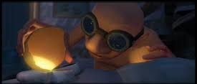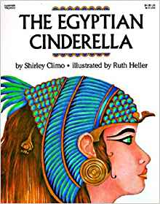

**Science:**

* Sc3/2.2a    identify that animals, including humans, need the right types and amount of nutrition, and that they cannot make their own food; they get nutrition from what they eat
* Sc3/2.2b    identify that humans and some other animals have skeletons and muscles for support, protection and movement.

**PSHE:**

|  |
| --- |
| * Celebrating Differences * Focus on Family – how every family is different and we should be happy we are all unique * Highlighting each other’s strengths * Discussing bullying and what a bystander is |

**Religious Education:**

* Christianity – why is Christmas so important for Christians?
* Birth of Jesus Christ – who was he? Why is he so important? Why do Christians celebrate Christmas?
* Nativity story sequencing/retelling

**P.E.:**

* Experience, rehearse and perform a range of dance from around the world
* Develop an understanding of the origins of dance
* Learn to count in beats matching movements to rhythm

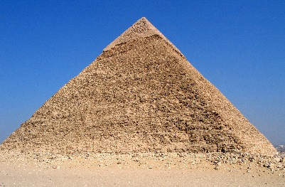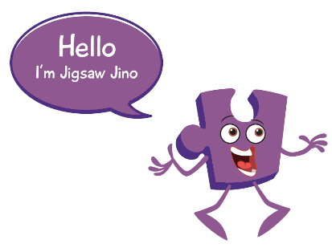

**Science:**

* Children to explore what constitutes a healthy balanced diet, evaluating the food/portion wheel of the food groups, classifying into groups
* Children will learn the scientific names for the basic skeletal system and transfer this knowledge to learning about types of skeleton in animals/humans
* Begin to investigate how muscles work, joints/sockets in the body

**WOW DAY:**

* Ancient Egypt Museum question hunt (Monday 13th November 2017)

**English Cross-Curricular Links:**

* History writing across Ancient Egypt topic
* Non-Chronological report in Science

**Maths Cross-Curricular Links:**

* 8 point compass (Geography)
* Time around the world (Geography)
* Counting in 4’s/8’s (Dance)
* Observations over time (Science)

**Intended Writing Outcomes:**

* Narrative Writing (focus on the story mountain to write good quality: openings, build up, problem, resolution and endings)
* Newspaper writing (tomb discovery of Tutankhamun)
* Non-fiction writing – Biography of Cleopatra
* Poetry (rehearsing) Christmas link

**Religious Education:**

|  |
| --- |
| * Christmas for Christians – customs and  traditions * Why it is so important to them |

**P.E.:**

* Children to experience a form of dance from somewhere around the world each week during additional 1 hour P.E. session.
* Children to research about roots of dancing from around the world
* Children to use Maths of counting in 4’s and 8’s to rehearse beats.

**PSHE:**

(same as above)

**Music:**

* Drumming until Christmas

**Year 3 Autumn 2 2017  
The Dream-Giver/Egyptian Cinderella  
Activities/Outcomes**

**Computing:**

* Create an e-book linked to their own narrative of the Dream-Giver

**Art/Design Technology:**

* Learn about Mondrian and his biography
* Understand pattern and how he used the primary colours to guide his work
* Evaluate and comment on a range of patterns

**History:**

* Understand how successful the Ancient Egyptians were
* Research and learn about Egyptian Pharaoh’s (Tutankhamun/Cleopatra)
* Exploring Ancient Egyptian after-life belief and comparing it to Religion in 21st CE
* Mummification Process