**Computing:**

* design, write and debug programs that accomplish specific goals, including controlling or simulating physical systems; solve problems by decomposing them into smaller parts
* use sequence, selection, and repetition in programs; work with variables and various forms of input and output
* use logical reasoning to explain how some simple algorithms work and to detect and correct errors in algorithms and programs
* understand computer networks including the internet; how they can provide multiple services, such as the world wide web; and the opportunities they offer for communication and collaboration

**Year 3 Spring 1   
Can the earth shake, rattle and roll?  
National Curriculum Links  
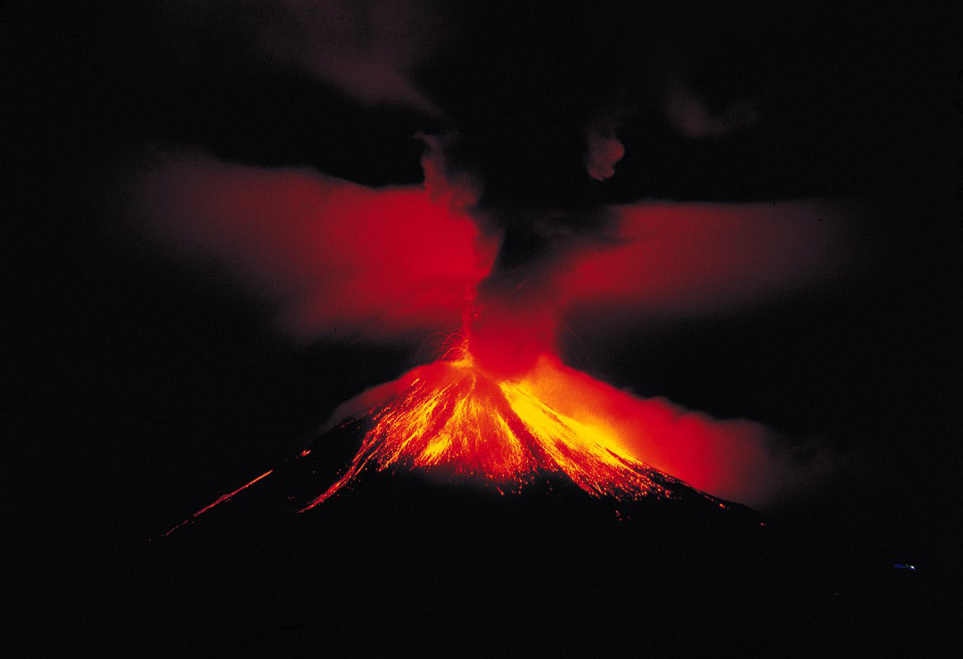**

**History**

* know and understand significant aspects of the history of the wider world, the nature of ancient civilisations, the expansion and dissolution of empires (leading in to changes in Britain from the Stone Age to Iron Age
* understand the achievements of the earliest civilisations through an in-depth study
* understand historical concepts and use them to make connections, contrasts, frame historically valid questions and create structured accounts
* Learning about Greek and Roman mythology

**Art/Design Technology:**

* understand and apply the principles of a healthy and varied diet
* prepare and cook a variety of predominantly savoury dishes using a range of cooking techniques
* understand seasonality, and know where and how a variety of ingredients are grown, reared, caught and processed.

**Music (taught through Music service this term):**

* Appreciate and understand a wide range of high-quality live and recorded music drawn from different traditions and from great composers
* play and perform in solo and ensemble contexts, using their voices and playing musical instruments with increasing accuracy, fluency, control and expression
* improvise and compose music for a range of purposes using the inter-related dimensions of music
* listen with attention to detail and recall sounds with increasing aural memory

**Geography:**

* knowledge of places and location locally and more globally
* physical characteristics and locations of volcanoes/rock formations and climate
* using maps, land use and map work to locate volcanoes
* beginning to use eight points of a compass

**Religious Education:**

* AT1 – learning from religions and about other religions (Christianity)

**PSHE (Jigsaw) :**

**P.E.:**

* swim competently, confidently and proficiently over a distance of at least 25 metres
* use a range of strokes effectively [for example, front crawl, backstroke and breaststroke]
* perform safe self-rescue in different water-based situations.

**Science:**

       • Compare and group together different kinds of rocks on the basis of their appearance and simple physical properties

* Describe in simple terms how fossils are formed when things that have lived are trapped within rock
* Recognise that soil are made from rocks and organic matter.

**PSHE:**

* Jigsaw – Dreams and Goals
* Staying motivated when doing something challenging
* Keep trying even when its difficult
* Work well with a partner or in a group
* Have a positive attitude
* Help others to achieve their goals
* Working hard to achieve own goals

**Maths Cross-Curricular Links:**

* Weighing food during DT (Measure)
* Statistics (Science Rock collection)
* Dates/Years in History (Time)
* Volcano top trump cards (Number)

**English Cross-Curricular Links:**

* Pebble in my Pocket – English cross-curricular with Science Rocks – Reports
* History – Stone Age/fossil formation

**Science: Rocks**

* Identifying/Classifying Rocks
* Rock characteristics descriptions
* Sedimentary/Igneous/Metamorphic (Sedimentary sandwiches DT Cookery link)
* Fossil formation (History Stone Age link/English Pebble in my Pocket link)

**Religious Education:**

* Jesus Christ and miracles
* Focus on the healing of the blind man and reading of the story “Bear feels sick”
* The Paralysed man – PSHE link to differences

**Music:**

* Taught through Music Service

**Computing:**

* iProgram Unit – using scratch software to design and debug a programme about themselves (PSHE link).

**WOW DAY:**

* Google Expeditions lesson – (app) visiting Mount Vesuvius.

**Year 3 Autumn 2   
Can the earth shake, rattle and roll?  
Activities/Outcomes  
**

**P.E.:**

* Children to take part in weekly swimming sessions (Monday pm)
* In addition to swimming, children are to experience a weekly professional Rugby Coach session to build up participation in team games and learning a range of tactics (Tuesday 1-2pm).

**Art/Design Technology:**

* Designing, making and evaluating a bread-based product with a filling for lunch
* Using pastels and varied techniques to display volcanoes and their texture

**History:**

* researching famous volcanic explosions of the past, including Vesuvius
* rock formations over time
* frame historically valid questions regarding volcanic formation